MiSACWIS Project

CF55 – Find a Resource Screen Specification
Version 1.9

March 9, 2016

Prepared for:


120 N. Washington Square
SACWIS Project, 3rd Floor
Lansing, MI 48933

Prepared by:

Revision Log
Version | Date | A/D/C (Add, Delete, Change) | Author | Document Section # | Description
0.1 | 07/18/2011 |  | Robyn Pratt-Barr |  | Initial version
1.0 | 08/25/2011 |  | Robyn Pratt-Barr |  | Approved
1.1 | 08/31/2011 | A/C/D | Mike Stubbs | Field Grid | Quality Assurance Review  Removed all ‘Remove’ references based off of OH functionality deleted in TN.  Updated: To Be Type, To Be Size, To Be Align, To Be Calculations and To Be UI Validation Section 3.1.3  Updated information highlighted in yellow.  No functionality affected.
1.2 | 11/03/2011 | A/C/D | Robert LaBarre | Field Grid | Removed Provider Reference Type and Reference Number.  Removed Percent Match column.  Modified Provider ID to MiSACWIS Provider ID.  Added label detailing how matching will be done.  Changes were to fulfill Change Control 1220.
1.3 | 04/04/2012 | A,C | Samaad Seales | 3.1.2, 3.1.3 | CC#0923
1.4 | 08/06/2012 | C | Robert LaBarre | 2.1.1, 2.1.2 | Changes per CC #14036 & 15403
1.5 | 01/24/2013 | C | Robert LaBarre | 2.1.1, 2.1.2 | Further clarifications to Copy/Select hyperlinks per CC #26731
1.6 | 03/31/2014 | A | Robert LaBarre | 2.1.11 | Changes per CC #46082
1.7 | 06/23/2014 | D | Mike Stubbs | 2.1.1  2.1.2.18 | CC#DTMB00061334  Remove references to ‘Copy’ functionality
1.8 | 02/16/2016 | A | Robyn Pratt-Barr | 2.1.1  3.1.2 | CC#DTMB00106444  Added Cancel Command Button
1.9 | 03/09/2016 | A | Robyn Pratt-Barr | 2.1.2  3.1.2  3.1.3 | CC #103511
Table of Contents
1 Introduction 5
1.1 Purpose 5
1.2 Scope 5
2 Use Case Details 6
2.1.1 Action Buttons/Hyperlinks 6
2.1.2 Business Rules 7
2.1.3 Security Requirements 10
2.1.4 Screen Navigation 10
2.1.5 Tab Order 10
2.1.6 Pre-Conditions 10
2.1.7 Ticklers 10
2.1.8 Notifications 10
2.1.9 Calendar 11
2.1.10 Reports 11
2.1.11 Notes and Assumptions 11
3 Screen Details 12
3.1 S01 – Provider Search Screen 12
3.1.1 As Is – Screen Mock Up 12
3.1.2 To Be – Screen Mock Up 13
3.1.3 Screen Fields 14
3.1.4 Action Buttons/Hyperlinks 19
3.1.5 Business Rules 19
3.1.6 Screen Navigation 19
3.1.7 Pre-Conditions 19
3.1.8 Reference Values 19

List of Figures
Figure 1 – Provider Search Screen – Existing Screen Mock Up 12
Figure 2 – Provider Search Screen – Updated Screen Mock Up 13

Introduction

Purpose
Enable users to search for, and optionally return results for, a Provider.

Scope
This Use Case describes how to search for a Provider in the MiSACWIS Provider Directory for maintenance, information, and non-service related data selection (i.e. linking to other MiSACWIS records).
Data Selection Search: Data selection searches are completed with the intent of selecting existing records to bring back data to the active screen from whence the search started. These searches start and end on the same business process screen, and the data created during the search process is brought back and displayed on the calling screen.

Use Case Details

Action Buttons/Hyperlinks
Status (Keep/Add/Modify/Delete) | Label | Type | On Click Action/Navigation
Keep | Search | Button | Current screen data will be cached and search results will be presented.
Keep | Clear Form | Button | Removes all previously entered search criteria.
Delete | View | Hyperlink | Current screen data will be cached and the System will present the selected Provider Overview (RM08) page. Only applies to users with view-only permissions.
Keep | Provider Name/ID | Hyperlink | launches View Provider Summary on RM08 (See BR)
Modify | Select | Hyperlink | On data retrieval search page only. Only appears for MiSACWIS provider records. View Provider Summary on RM08 for the chosen Provider (See BR). Applies to users that have the ability to edit the record.
Modify | Add Non-DHS Provider | Button | On data retrieval search page only; Takes the worker to create a Non-DHS provider on the Provider Facility Information Page (RM39), with a Provider Type of Non-DHS Provider.
Keep | Close | Button | Close CF55 – Only visible when the screen has been entered from a workflow and a search has been performed. Closes screen and returns to the calling screen in the workflow.
Delete | Add Network Provider | Button | Takes the worker to RM38 in add mode to create a Residential Provider with a Provider Type of Network Provider
Delete | Add Residential Facility | Button | Takes the worker to RM38 in add mode to create a Residential Provider with a Provider Type of Residential Facility
Keep | Help | Hyperlink | Screen-level help will appear in a separate browser window.
Delete | Copy | Hyperlink | Only appears for Bridges provider records (no Provider_Id in MiSACWIS. Launches IF902c use case Scenario 2 and launches RM39 use case.
Add | Cancel | Button | Closes CF55 – Only visible when the screen has been entered from a workflow where selection/retrieval of provider record(s) is an option. Closes screen and returns to the calling screen in the workflow without returning any information to calling screen.

Business Rules
No. | Status (Keep/Add/ Modify/Delete) | Business Rule Description | Modified Business Rule Description | Execution Event (field tab out/save etc) | Error Msg Code  To be completed by Development Team
1 | Modify | The worker can perform a wild card or “root search” on the Resource Name, Street Name, and City, and first and last Member name. | The worker can perform a "root search" (i.e. Soundex search) on the Provider Name. | Screen Open
2 | Delete | The worker can perform a wild card search on the Provider Name, Street Name, and City, and first and last Member name. |  | Screen Open
3 | Modify | The System will only allow a search on Address if City and State, or Zip Code, or County, or Region is entered. | The System will only allow a search on Address if City and State, or Zip Code, or County is entered. | Executing Search
4 | Keep | When the worker enters a value in the Provider ID Field, all other fields are ignored and any information previously entered is removed. |  | Executing Search
5 | Delete | When the worker enters a value in the Provider Type field, the Provider Sub-Type field should be filtered based on the Provider Type. |  | Selecting Provider Type
7 | Keep | The Organization field should default to the employing Organization of the logged in worker |  | Screen Open
8 | Delete | When the Provider Search page is accessed through the high level Search hyperlink, or some other generic search navigation link, the Retrieve hyperlinks should not display. Retrieve hyperlinks should only display when the business process supports the link of the Provider to another piece of work. |  | Screen Open
9 | Keep | The System will search for the current primary address. |  | Executing Search
10 | Keep | The System will return and display the current primary address associated to the Provider record. |  | Executing Search
11 | Modify | The Create Resource process can only be used for the creation of Non-DCS Resources and Network Providers. | The Create Provider process can only be used for the creation of Non-DHS Providers. | Selecting Add Non-DHS Provider.
12 | Keep | Service Type will not be enabled unless Service Category is selected, and will be based on Service Category. Changing Service Category will clear the Service Type and Service Description. |  | Select Service Category
13 | Keep | Service Description will not be enabled unless Service Type is selected, and will be based on Service Type. Changing Service Category will clear the Service Description. |  | Screen Open/Changing Service Category
14 | Keep | When CF55 is accessed from a workflow, the screen is presented as a single screen (no tabs). If it is presented by navigating through the general Search hyperlink, it is presented as one of two tabs, with a tab label of Provider Search. |  | Screen Open
15 | Delete | When the screen opens, the County criterion is filled with all Michigan counties plus <blank> (default); the Region criterion is filled with all Michigan Regions other than Central Office plus <blank> (default). If the user selects a County, the Region defaults to the associated Region. If the user selects a Region, the County is populated with the associated counties plus <blank> (default). If <blank> is selected for either County or Region, the two fields reset to the screen open defaults. |  | Screen Open
16 | Keep | When a search is performed, Providers must be returned if the active or any inactive Provider names match the Provider Name filter criterion. |  | Executing Search
17 | Keep | Provider Name/ID field is only a hyperlink when CF55 is called from another use case as a sub function search. |  | Screen Open
18 | Delete | When a Provider Search is run and results are returned from IIR, records which are current MiSACWIS records will have the Select hyperlink displayed. Records that are returned from Bridges, which don’t have a MiSACWIS Provider_Id, will display the Copy hyperlink. |  | Search Results Returned
19 | Add | When a search is performed using the License Number and less than 11 characters is entered the following error message will display:  License Number must be valid 11 characters in length. |  | Executing Search
20 | Add | When a search is performed using the License Number and special character(s) is entered the following error message will display:  Valid License Number can only be alphanumeric. |  | Executing Search
21 | Add | When a search is performed using the MiSACWIS Provider ID and License Number the following error will display:  Search Criteria Invalid. Cannot search with both MiSACWIS Provider ID and License Number. |  | Executing Search

Security Requirements
No. | Status (Keep/Add/Modify/Delete) | Security Requirement
1 | Keep | Create Security:  N/A
2 | Keep | Read Security:  Worker (anyone with MiSACWIS access)
3 | Keep | Update Security:  N/A
4 | Keep | Delete Security:  N/A

Screen Navigation
No. | Status (Keep/Add/Modify/Delete) | To Screen Navigation Path
1 | Keep | Provider tab after selecting the Search hyperlink on the Home page.
2 | Keep | Directory sub-tab after selecting the main Provider tab.
    - Tab Order
No. | Status (Keep/Add/Modify/Delete) | Screen name

Pre-Conditions
No. | Status (Keep/Add/Modify/Delete) | Pre-Condition
1 | Keep | User has access to MiSACWIS

Ticklers
Status (Keep/Add/Modify/Delete) | Tickler Name | Trigger Action | Tickler Generation Business Rule & Description | Tickler Removal Business Rule | Tickler Text
Status (Keep/Add/Modify/Delete) | Tickler Role
N/A

Notifications
Status (Keep/Add/Modify/Delete) | Notification Name | Trigger Action | Message Business Rule & Description | Message Text
Status (Keep/Add/Modify/Delete) | Notification Role | Trigger Action | Message Business Rule & Description | Message Text
N/A

Calendar
Status (Keep/Add/Modify/Delete) | Calendar Name | Trigger Action | Calendar Event Generation Business Rule & Description | Calendar Event Date and Time Business Rule | Calendar Event Text
Status (Keep/Add/Modify/Delete) | Calendar Role

Reports

Notes and Assumptions

When a provider search is initiated from CF55, results will be returned per the matching criteria from Bridges and MiSACWIS. Results that are returned from Bridges will be displayed as is since there is currently no issue displaying the information associated to these records. However, due to limitations in IIR, for MiSACIWS search results the provider ID that is returned from the search will be used to do a secondary search in MiSACWIS to get all types and statuses attached to that provider so that these results display correctly to the user. The score and source system attributes returned from IIR will still be used for these results.

Screen Details

S01 – Provider Search Screen

As Is – Screen Mock Up
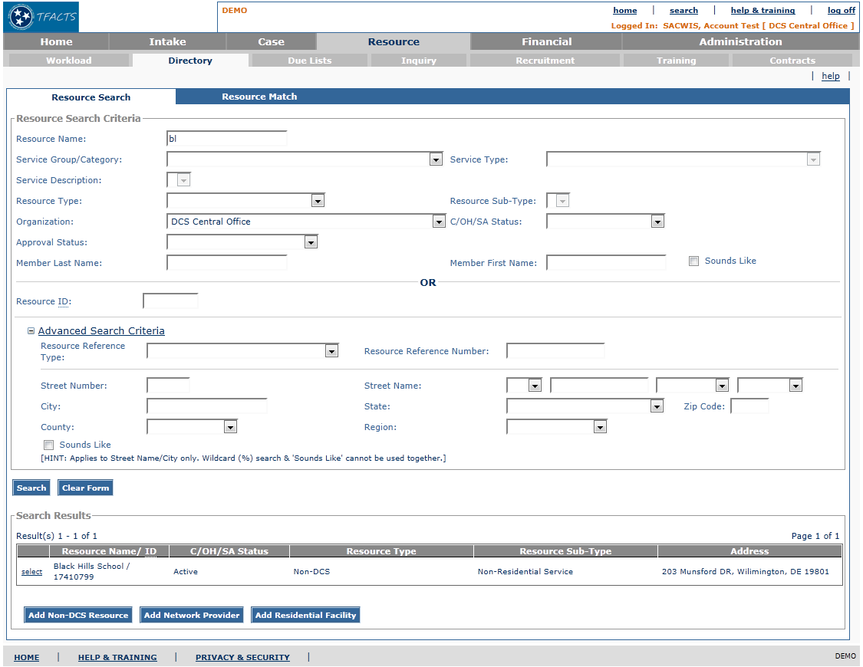
Figure 1 – Provider Search Screen – Existing Screen Mock Up

To Be – Screen Mock Up
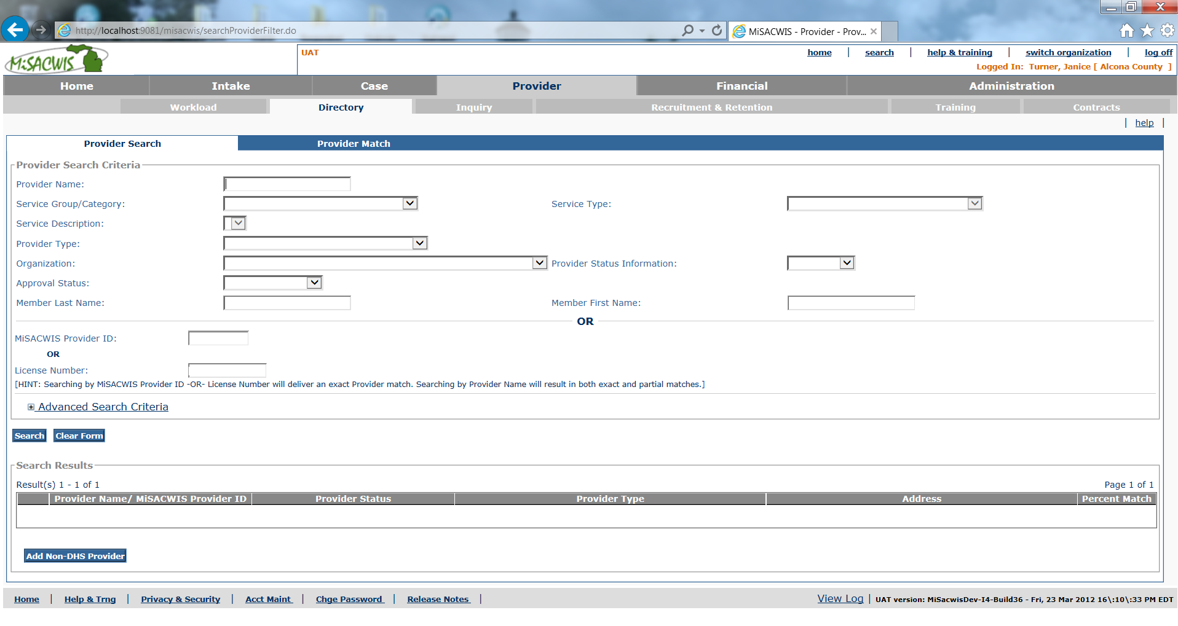
Figure 2 – Provider Search Screen – Updated Screen Mock Up

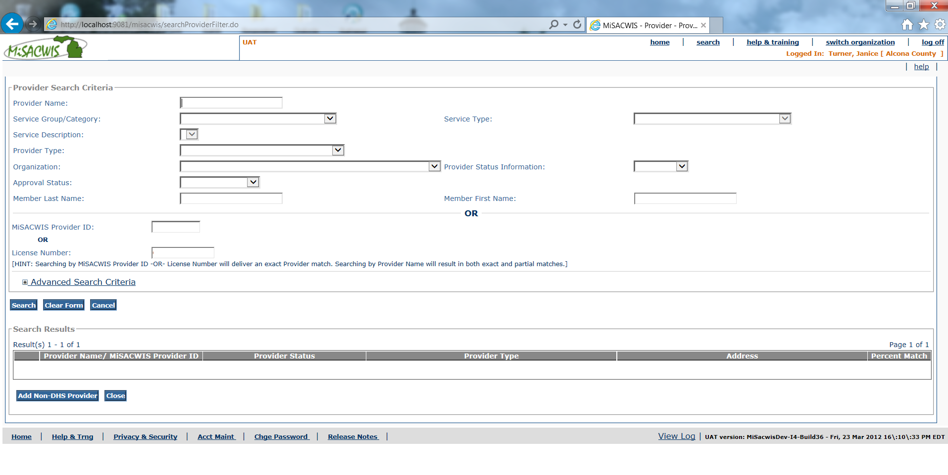
Figure 3 – Provider Search Screen (when accessed via workflow) – Updated Screen Mock Up

Screen Fields
Status (Unchanged/Add/Modify/Delete) | As Is Class.Attribute Name | To Be Class.Attribute Name | As Is Display Name | To Be Display Name | To Be Type | To Be Align | To Be Size | To Be Read Only | To Be Calculation | To Be Edit Mask | To Be UI Validation
Modify | N/A | N/A | Resource Search Criteria | Provider Search Criteria |  | L | N/A | T
Modify | N/A | N/A | N/A | [HINT: Searching by MiSACWIS Provider ID –OR- License Number will deliver an exact Provider match. Searching by Provider Name will result in both exact and partial matches.] | Label | L | 200 | T
Modify | ProviderName.nameText | ProviderName.nameText | Resource Name | Provider Name | Text Field | L | 100 | F |  |  | User Entered  Not Required
Keep | GroupCategory.CategoryType | GroupCategory.CategoryType | Service Group/Category | Service Group/Category | Drop down List | L | 100 | F |  |  | User Selected  Not Required
Keep | GroupCategory.serviceType | GroupCategory.serviceType | Service Type | Service Type | Drop down List | L | 100 | F |  |  | User Selected  Not Required  If service category is selected, type dropdown will be filtered based on selected category.
Keep | ServiceType.serviceDesc | ServiceType.serviceDesc | Service Description | Service Description | Drop down List | L | 100 | F |  |  | User Selected  Not Required  If service type is selected, description dropdown will be filtered based on selected service type.
Modify | ProviderType.typeCode | ProviderType.typeCode | Resource Type | Provider Type | Dropdown List | L | 100 | F | Domain Code: ProviderType |  | User Selected  Not Required
Delete | ProviderType.typeCode | ProviderType.subTypeCode | Resource Sub-Type | Provider Sub-Type
Keep | ProviderType.agencyId | ProviderType.agencyId | Organization | Organization | Dropdown List | L | 100 | F | Use Agency Name from Agency |  | User Selected  Not Required
Modify | ProviderStatus.statusCode | ProviderStatus.statusCode | C/OH/SA Status | Provider Status Information | Drop down List | L | 100 | F | Domain Code: ProviderCOHSAStatus |  | User Selected  Not Required
Keep | ProviderType.currentStatusCode | ProviderType.currentStatusCode | Approval Status | Approval Status | Drop down List | L | 100 | F | Domain Code: ProviderTypeStatus |  | User Selected  Not Required
Modify | Provider.providerId | Provider.providerId | Resource ID | MiSACWIS Provider ID | Text Field | L | 22 | F |  |  | User Entered  Not Required
Add |  | ProviderLicense.licenseNumber |  | License Number | Text Field | L | 11 | F |  |  | User Entered  Not Required
Keep | Person.first_name | Person.first_name | Member First Name | Member First Name | Text Field | L | 100 | F |  |  | User Entered  Not Required
Keep | Person.last_name | Person.last_name | Member Last Name | Member Last Name | Text Field | L | 100 | F |  |  | User Entered  Not Required
Delete | N/A | N/A | Sounds Like | Sounds Like | Checkbox |  | N/A
Keep | N/A | N/A | Advanced Search Criteria | Advanced Search Criteria | Expando |  | N/A
Modify | ProviderReference.providerReferenceTypeCode | ProviderReference.providerReferenceTypeCode | Resource Reference Type | Provider Reference Type | Drop down List | L | 100 | F | Domain Code: ProviderReferenceType
Modify | ProviderReference.providerReferenceNbr | ProviderReference.providerReferenceNbr | Resource Reference Number | Provider Reference Number | Text Field | L | 30 | f
Keep | Address.streetNbr | Address.streetNbr | Street Number | Street Number | Text Field | L | 20 | F
Keep | Address. preDirectionalCode | Address.preDirectionalCode | (prefix) | (prefix) | Drop down List | L | 100 | F | Domain Code: Direction |  | User Selected
Keep | Address.streetName | Address.streetName | Street Name | Street Name | Text Field | L | 200 | F |  |  | User Entered  Not Required
Keep | Address.streetSuffixCode | Address.streetSuffixCode | (suffix) | (suffix) | Drop down List | L | 100 | F | Domain Code: StreetSuffix |  | User Selected  Required
Keep | Address.postDirectionalCode | Address.postDirectionalCode | (post directional code) | (post directional code) | Drop down List | L | 100 | F | Domain Code: Direction |  | User Selected  Required
Keep | Address.cityName | Address.cityName | City | City | Text Field | L | 60 | F |  |  | User Entered  Not Required
Keep | Address.StateCode | Address.StateCode | State | State | Drop down List |  | 100 | F | Domain Code: State |  | User Selected  Required
Keep | Address.zip5Code | Address.zip5Code | Zip Code | Zip Code | Text Field |  | 5 | F |  |  | User Entered  Not Required
Keep | Address.countyCode | Address.countyCode | County | County | Drop down List |  | 100 | F | Domain Code: County |  | User Selected  Required
Delete | Address.countyCode | N/A | Region | N/A
Delete | N/A | N/A | Sounds Like | Sounds Like | Checkbox |  | N/A
Delete | N/A | N/A | (Hint: Applies to Street Name/City only. Wildcard (*) search & 'Sounds Like' cannot be used together.) | N/A | Note |  | N/A
Keep |  |  | Search Results | Search Results | Group Header | L | N/A | T
Modify | ProviderName.nameText / Provider.providerId | ProviderName.nameText / Provider.providerId | Resource Name/ ID | Provider Name/MiSACWIS Provider ID | Display Text | L | 122 | T
Modify | ProviderStatus.statusCode | ProviderStatus.statusCode | C/OH/SA Status | Provider Status | Display Text | L | 100 | T
Modify | ProviderType.typeCode | ProviderType.typeCode | Resource Type | Provider Type | Display Text | L | 100 | T
Delete | ProviderType.subTypeCode | ProviderType.subTypeCode | Resource Sub-Type | Provider Sub-Type | Varchar2 |  | 30 | T
Keep | Address.addressId | Address.addressId | Address | Address | Display Text | L | 22 | T |  | Use Standard Address Format

Action Buttons/Hyperlinks
Status (Keep/Add/Modify/Delete) | Label | Type | On Click Action/Navigation

Business Rules
No. | Status (Keep/Add/ Modify/Delete) | Business Rule Description | Execution Event (field tab out/save etc)

Screen Navigation
No. | Status (Keep/Add/Modify/Delete) | To Screen Navigation Path
1 | Keep | Provider

Pre-Conditions
No. | Status (Keep/Add/Modify/Delete) | Pre-Condition

Reference Values
No. | Status (Keep/Add/Modify/Delete) | To Be Class Attribute | Domain Code | Short Desc | Ref Data Code
1
2

